Sam Harwood

sharwood@umass.edu

Sports betting in the united states: A history aND RECOMMENDATIONS

Sport 335 ISH, May 2021

**Introduction**

Ever since the Professional and Amateur Sports Protection Act of 1992 (PASPA) was repealed in 2018, states have rushed to legalize sports betting within their borders. Legally, sports betting is already a billion-dollar industry in the United States despite its newness and accessibility problems, and illegally the industry is much larger (Sacks & Ryan, 2017, p.8). The goal of this paper is to comprehensively analyze the industry and make a recommendation on the best courses of action states can take to grow the industry while protecting consumers.

**PASPA History** **and Repeal**

The Professional and Amateur Sports Protection Act was a response to national concern about the integrity of professional sports. According to a 1989 report by a special counsel to the commissioner of Major League Baseball, Pete Rose had placed wagers on a number of Cincinnati Reds games while he was manager of the team in 1987. (Boswell, 2019, p. 116-117). Less than 2 years later, PASPA was signed into law, making it unlawful for states to “sponsor, operate, advertise, promote, license, or authorize by law ... [a] betting, gambling, or wagering scheme based ... on one or more competitive games in which amateur or professional athletes participate . . . or on one or more performances of such athletes in such games." (p. 117). This hardline stance against sports gambling was not maintained for long. The act was repealed in the 2018 *Murphy v. National Collegiate Athletic Association* decision which found that the “Professional and Amateur Sports Protection Act provision prohibiting state authorization of sports gambling schemes violates the anti-commandeering rule and is unconstitutional”. This was not a unanimous decision, as there was a 7-2 vote in deciding that PASPA violated the anti-commandeering rule and 6-3 vote on declaring the entire law unconstitutional. Justice Ruth Bader Ginsburg wrote the dissenting opinion, disagreeing with the fact that PASPA was to be made unconstitutional even with the commandeering portions taken away. “Deleting the alleged “commandeering” directions would free the statute to accomplish just what Congress legitimately sought to achieve: stopping sports-gambling regimes while making it clear that the stoppage is attributable to federal, not state, action” (*Murphy v. NCAA,* 2018). By making the law entirely unconstitutional, regulation of sports betting was moved entirely out of the hands of the federal government and was instead given to state governments. With this decision, states gained free reign in accessibility decisions and in regulation of sports betting.

**Post PASPA Legalization**

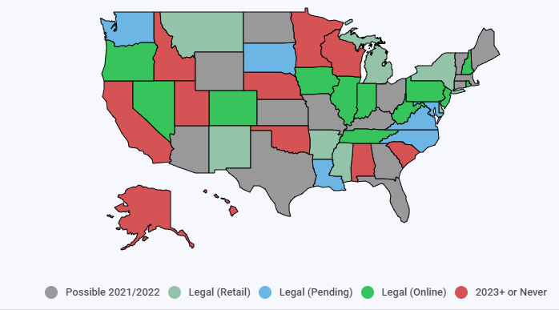Since PASPA’s repeal, many states have acted quickly to legalize forms of sports betting. *Figure 1* depicts the status of sports betting by state and the means by which one can bet in each state. 21 states have legalized sports betting so far, with legislation pending in 20 more. Excluding Nevada (which was grandfathered into the Act and had a monopoly on US legal sports bets), Delaware became the first state following the repeal to legalize sports betting in June 2018. While there is significant interest in legalizing sports betting, states vary markedly in their offerings. For example, some states have multiple mobile and in-person options for placing sports bets, while others only allow bets to take place in physical sportsbooks or require mobile betting registration at physical locations. In any case, legal sports betting is in high demand. Per a 2016 EY consumer survey, 28% of United States adults bet on sports, and “respondents

Source: The Action Network

Figure 1: Sports betting legalization by state

indicated that they would significantly increase their sports betting activity if sports betting was more widely legalized” (Sacks & Ryan, 2017, p. 8).

**Demographics of Sport Bettors**

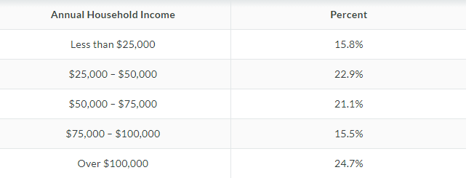Differences in statewide ease of access to wagering comes with different state to state philosophies on how accessible sports betting should be. For example, per the Massachusetts *White Paper on Sports Betting*, a noted implementation concern is the “desire to identify and mitigate any potential negative externalities associated with the introduction of sports betting, including efforts to promote responsible gaming” (Connelly & Stempeck, 2018, p.16). Accessibility is a major concern for many states. Internet casino gaming (IGaming) is only legalized in a few states due to concern that easy access would enable compulsive gamblers, and similar concerns are in play with allowing mobile sports betting. However, an early look at the demographics of sports bettors indicates that a richer and more educated demographic is betting on sports than standard casino problem gamblers. Concerning gambling addicts, a report from the U.S. National Library of Medicine states that, “Among the socio‐demographic factors reported to correlate with problem gambling are male gender, lower education, younger age, being single or divorced, being unemployed or laid off from work, sick leave, retirement on pension for health reasons and lower income” (Castrén et al., 2018). While sports bettors still tend to be male, the similarities largely end there. According to a 2019 poll conducted by SportsBettingDime.com, most bettors earn more than the median household income of 63,000 or higher, and 59.6% of bettors hold a bachelor’s degree or higher, a very high number considering only 30.9% of Americans over 25 possess a college degree. Additionally, 65.6% of sports bettors invest in the stock market or other securities and 71% view betting on sports as a form of investment (SportsBettingDime.com). With the similarities between sports bettors and problem gamblers minimal, the need to keep more control of gamblers by reducing accessibility to sports betting does not seemingly exist. However, in a rapidly expanding industry the demographic may not consist primarily of white-collar speculators for long. As sports wagering becomes increasingly popular and more available to the public, bettor demographics could potentially shift massively.

Figure 2: Sports bettors by income

Source: SportsBettingDime.com

Figure 3: February 2020-21 sports betting handle

Source: American Gaming Association Commercial Revenue Tracker

**Financials of Mobile vs Physical Betting**

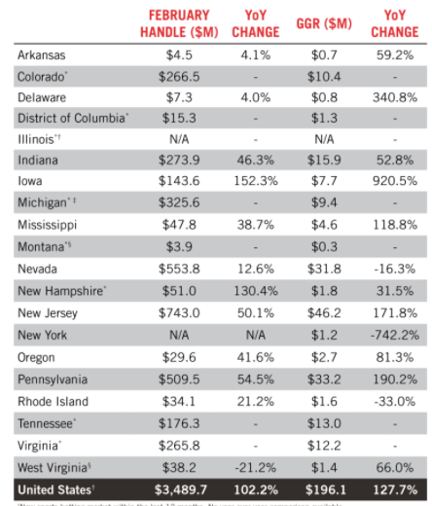States that have increased access to sports wagering via mobile betting have also generated much more revenue than states with only physical sportsbooks. As showcased in *Figure 3,* the states with the largest year-over-year increases in sports betting handle have some form of mobile betting legalized, up to Mississippi, which had the seventh largest increase. While the COVID-19 pandemic has driven more mobile traffic, the February figures were collected with most casinos reopened. A 2021 PR Newswire Report found that 911 out of 998 United States casinos have reopened since casinos started reopening in Mid-May. Clearly, consumers value the easier access to betting that comes with mobile options, and in a world increasingly dominated by technology this trend will likely continue.

**Integrity Concerns**

Decidedly, there are concerns with suddenly pivoting from a hardline stance against sports-betting to allowing every state to regulate the issue at its own discretion. Concerns regarding the integrity of sport competition are again very much relevant as wagering on outcomes is allowed once more. As recently as 2007, the NBA itself dealt with a major scandal where Tim Donaghy, a referee, was caught in a scheme where he reportedly fixed games that a friend bet large sums of money on. Per *The Observer,* Donaghy continues to deny that he ever made calls to fix games, but ESPN recently published an in-depth article, featuring dozens of interviews that conflict with Donaghy’s story (Ford, 2019). Collegiate athletics are considered even more vulnerable to potential fixing as athletes are unpaid. A 2019 piece in the *West Virginia Law Review* points to 5 different collegiate point shaving (when teams intentionally fail to cover a spread) scandals from history, one involving 32 players from 7 different schools. “A major negative that could come with the legalization of sports betting is gamblers infiltrating the NCAA by offering college athletes money to shave points during a game or throw a game all together” (Robb, p. 376). To combat this problem, per the Massachusetts *White Paper on Sport Betting* some professional leagues have argued for “integrity fees” to fund integrity monitoring. While the report notes that there are various different viewpoints on the feasibility and necessity of such fees, integrity fees need to be considered amidst the public policy desire to transition sports betting activity from the black market to the legal market (Connelly & Stempeck, 2018, p. 25). If athletes aren’t monitored in some way, situations could occur where they could place bets through different users or potentially be bribed off the record.

**State Regulation Concerns**

Additionally, there is a level of concern in allowing states free reign in dictating sports betting regulation. Richard Batcheldor, a partner at global law firm Ropes and Gray, makes a note of the danger that could ensue from states being fully in control.

“States need to be careful that they don’t try to capture a market share and then leave their neighboring state with different regulations that will eclipse whatever they are trying to do in that state to raise revenue . . . We are in the very early stages of this, but when we look back ten years from now, I hope we don’t look back and say, ‘wow, I can’t believe we had those initial regulations they seem so quaint now.’ We should allow consumers to do this responsibly” (Goodfriend et al., 2018, p.11).

This is most certainly an issue. If states feel financial pressure to adopt less stringent regulation if neighboring states are stealing revenue from their residents by allowing greater accessibility to betting or less tax, regulation and promotion of responsible gambling could be thrown out the window in the interest of making profit.

**The Illegal Betting Industry**

While there could have very well been benefits to a federally regulated approach to sports betting, PASPA has been repealed and states will be in control of regulation outcomes for the foreseeable future. To the detriment of both consumers and the United States, the illegal sports gambling industry has become exceptionally popular among United States consumers as bettors lacked a legal avenue to place bets until recently. Estimates of the size of the national illegal sports betting market vary, but per the Massachusetts White Paper on Sport Betting “it is safe to assume that the (United States) illegal sports betting market is in the tens of billions of dollars, if not over $100 billion (Connelly & Stempeck, 2018, p. 4). The white paper goes on to note several other advantages that would come with reducing the sports betting black market.

Figure 4: Tax rates by legalized states in 2019

“Reducing the black market has multiple advantages to a state government considering sports betting legalization as doing so will drive bettors to legal, taxable alternatives that are regulated and provide for consumer protections of the public, thus benefiting both the state as well as the bettors themselves. Reducing the size of the black market also has the potential to reduce enforcement costs associated with investigating and prosecuting illegal sports betting” (p. 17).

**Potential Consumer Protection from Legalization**

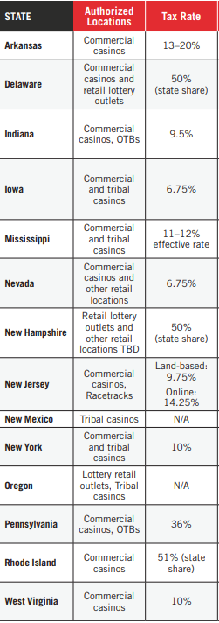With sports wagering legalized, in theory state governments can protect consumers while benefitting financially. As stated in the *Sports Bettors’ Bill of Rights* by the Sports Fans Coalition, offshore operators can decide if and when to pay out winnings and are not bound to act in good faith without regulatory oversight. This has been problematic in the past, with the New York Times and Wall Street Journal each reporting in the past about bettors losing thousands of dollars in winnings (Goodfriend et. Al, 2018, p. 9).

Source: American Gaming Association State of the States Report

**Taxation Approaches**

Regarding taxation, different states have taken different approaches. As shown in *Figure 4,* sports betting taxes range from 6.75% in Iowa to 51% in Rhode Island, a massive discrepancy (AGA, 2020, pg. 15). There are benefits and downsides to both approaches. A 2017 Oxford Economics report on sports betting made projections based on 3 tax rate scenarios: base, low, and high. Per the report, “In the Low Tax Rate Scenario, we assumed that sports betting operators would tend to set odds that were more attractive to bettors, would invest more in technology, content, and infrastructure, and would spend more on marketing and customer service” (Sacks & Ryan, p. 18). The inverse was expected to be true with a high tax rate, which could also push consumers back into illegal markets. “We anticipate operators would tend to set less attractive odds, invest less in technology, content, and infrastructure, and reduce marketing and customer service. These changes would be expected to make legal sports betting less attractive to some gamers relative to illegal alternatives” (p. 18). The plus side of a higher tax rate comes with greater revenues. “Overall, in the Higher Tax Rate Scenarios, gaming tax revenue is expected to increase relative to the Base Tax Rate Scenarios, as the higher tax rate more than offsets the decrease in gaming revenue” (p. 19). With increased government tax revenue comes the opportunity to allocate the money to public programs. For example, per legalsportsbetting.com in New Jersey the “Department of Human Services is the largest beneficiary of the revenue”, and in Nevada “education and health services are the key recipients of the money” (Molter, 2019). Other states are thought to put these funds towards similar purposes, although there is no way to see the cash flow.

**Best Practices for Revenue Generation**

Looking at overall best practices for generating revenue, states with high tax rates that allow relatively easy access to sports wagering are likely to generate more revenue than their counterparts. Highlighted in *Figure 5* is the gaming tax revenue the Oxford Economics report projects in annual revenue for the United States under different conditions of availability.

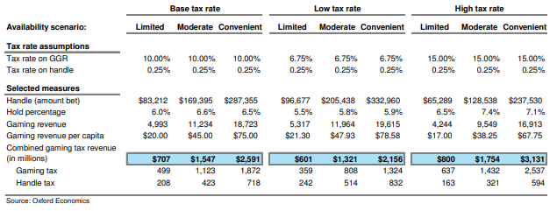

Figure 5: Projections for gaming revenue in the United States

Source: Oxford Economics

From this infographic, it appears that the scenario where nationally the tax rate is high and availability of sports betting mediums is convinient would be the most effective in generating revenue. A high tax rate is defined in the report as 15% of gross gaming revenue, and convenient availability means there is on-site betting available at casinos in additional to mobile betting (Sacks & Ryan, 2017, p. 16).

**Economic Impact**

Additionally, the newfound legality of sports betting and robust interest in the industry should create a significant amount of jobs. As shown in *Figure 6,* the sport industry could support over a hundred thousand jobs nationally in scenarios of moderate availability, and in scenarios with convenient availability and a base/low tax rate the industry could support over 200,000. Sports betting is also projected to contribute a staggering amount towards United States GDP, with GDP contributions projected to be around $20 billion or more in scenarios of convenient availability. A scenario with a low tax rate and convenient availability is projected to generate by far the most gaming revenue as well as jobs.

Figure 6: Economic Impact Projections for Sports Betting

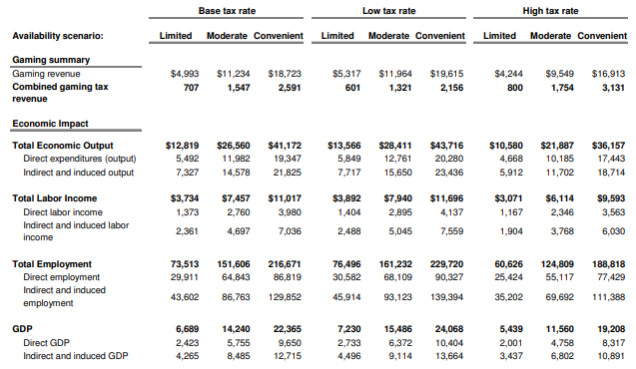

Source: Oxford Economics

**Conclusion/Recommendations**

Due to the infancy of the industry, it is too soon to make a discrete recommendation on best practices states can adopt. Convenient availability with a high tax rate is the best way to maximize revenue (Sacks & Ryan, 2017, p. 16)., but this approach could come with major negatives, financially and socially. A high tax rate might drive consumers back towards illegal offshore operators and result in less capital invested into wagering infastructure (Sacks & Ryan, p. 18)., and convenient availability could enable a new generation of compulsive gamblers. Important data such as updated demographic information and state gaming revenue per capita isn’t even widely available. Be that as it may, financially too much is at stake for states not to rush to realize profits that were previously going into illegal sportsbooks offshore. Cautiously, the best course of action for most states should be implementation of secure mobile betting owing to the vastly superior profits (AGA, 2021) and more extensive job creation (Sacks & Ryan, p. 24) states with mobile betting have realized, while taxing low enough to allow wagering infastructure to continue advancing (Sacks & Ryan, p. 18). As more information is made available about who is betting and which strategies generate more revenue, states need to be adapt in a manner where they maximize returns while also ensuring sports betting is conducted responsibily.

Sources

American Gaming Association. (2020, June 3). *State of the States 2020*

https://www.americangaming.org/resources/state-of-the-states-2020

American Gaming Association. (2021, April 2). *Commercial Gaming Revenue Tracker*.

https://www.americangaming.org/resources/aga-commercial-gaming-revenue-tracker/

Boswell, Daniel. (2019, Winter). *The Safest Bet: A Comprehensive Review of the Fall of PASPA and the Rise of Sport Betting.* University of Miami Business Law Rev. 115.

https://repository.law.miami.edu/umblr/vol28/iss1/5

Butler, Ryan. (2021, February 4). Where Is Sports Betting Legal? Projections for All 50 States. *Action Network*.

https://www.actionnetwork.com/news/legal-sports-betting-united-states-projections

Castrén, S., Kontto, J., Alho, H., Salonen, A. (2017, September 5). *The relationship between gambling expenditure, socio-demographics, health-related correlates and gambling behaviour- a cross sectional population-based survey in Finland.* US National Library of Medicine National Institutes of Health

https://ncbi.nlm.nih.gov/pmc/articles/PMC5763410

Connelly, Paul and Stempeck, Justin. (2018, February 28). *White Paper on Sports Betting*. Massachusetts Gaming Commission*.*

https://massgaming.com/wp-content/uploads/2C-Final-Draft-Sports-Betting-WP-2-28-18.pdf

Ford, Andrew. (2019, February 22). *Legalized sports gambling: beneficial or dangerous*? The Observer.

https://observer.case.edu/legalized-sports-gambling-beneficial-or-dangerous/

Goodfriend, D., Hess, B., Hankerson, D. (2018, August 1). *Sports Bettors’ Bill of Rights*. Sports Fans Coalition

https://www.sportsfans.org/sports_bettors_bill_of_rights_white_paper

Molter, Michael. (2019, July 20). *Where Does Sport Betting Tax Revenue Go?* legalsportsbetting.com

https://www.legalsportsbetting.com/news/where-does-sports-betting-tax-revenue-go/

Murphy v. National Collegiate Athletic Association, 584 U.S. ___ (2018).

https://supreme.justia.com/cases/federal/us/584/16-476/#tab-opinion-3901187

PR Newswire (2021, February 17). *COVID-19 Drives Commercial Gaming Revenue Down 31% in 2020 - Responsible Reopening Efforts, Sports Betting Help Industry Weather Pandemic.*

https://infoweb-newsbank-com.silk.library.umass.edu/apps/news/document-view?p=AMNP&docref=news/180B573294904458.

Robb, Haley. (2019, Fall). Hedge Your Bets: *How the Legalization of Sports Betting Could Be the Downfall of Intercollegiate Sports*. West Virginia Law Review

https://heinonline-org.silk.library.umass.edu/HOL/Page?handle=hein.journals/wvb122&id=1&collection=journals&index=

SportsBettingDime.com. (2020, May 8). *American Sports Bettors Pray for the Best- Who Bets on Sports in the US?*

https://www.sportsbettingdime.com/guides/research/survey-who-bets-on-sports/